The lake
The abiotic and biotic factors of drilling water

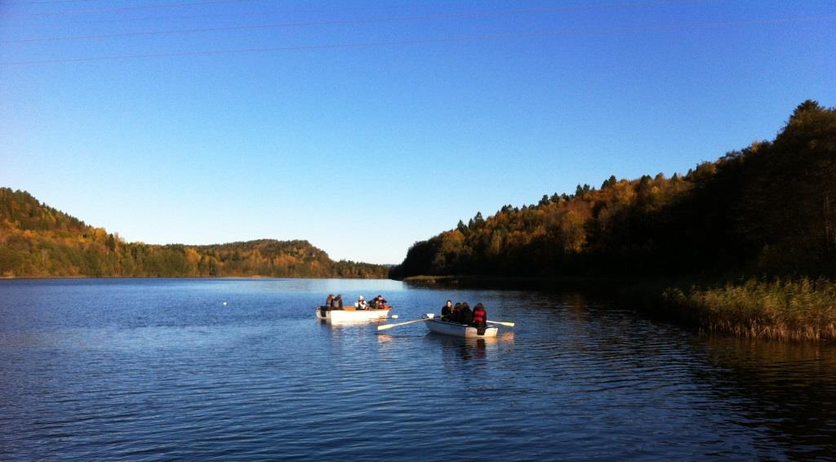
Figur 1 Borrevannet mot Nord

The lake is born
Most Norwegian lakes were formed at the end of the last ice age. Parts of the country were pushed down below the marine boundary due to the large inland ice (marine boundary 180 meters here). When the ice disappeared at the end of the ice age, the land began to rise. When the land rose, new lakes had formed. The lakes below sea level were filled with salt water and the lakes further up were filled with glacial water (fresh water). The lake was then nutrient-poor. After 10,000 years, Borrevannet is today at the end of its life and will eventually fill up with sand and gravel and become dry land.
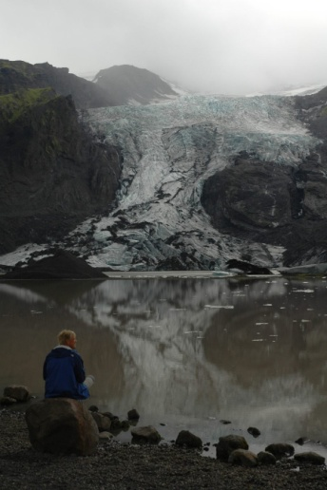

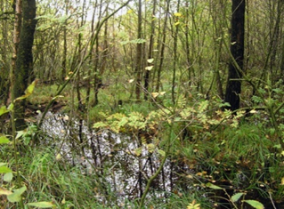
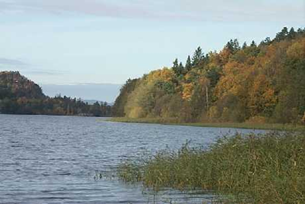

Fødsel 10.000 år senere Borrevannets død

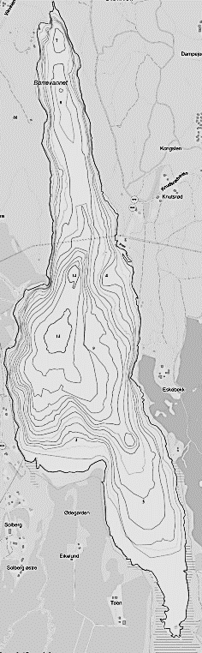
Oppgave 1.
Give a short description of the lake where you include a little about the formation of Borrevannet, what kind of terrain the lake is in and how the vegetation is around the lake today.
Description:____________________________________________________________________________________________________________________________________________________________________________________________________________________________________________________________________________________________________________________________________________________________________________________________________________________________________________________________________________________________________________________________________________________________________________________________________________________________________________________________________________________

Areal nedbørsfelt | 32 km²
Areal innsjø | 2,0 km²
Midlere dyp | 6,5 m
Største dyp | 15 m

Abiotic measurements
Equipment: Boat, life jacket, dredge, oars, sight disc, water binoculars, oxygen meter (teacher included), water collector / teacher included), several bottles for water samples, dram glass and plankton hoof. Remember stationery.

Task 2.
Sight depth and water color.
Use a white disc, a so-called sechi disc, and immerse it in the water until it is no longer visible. Then raise the dial until it is barely visible. To be able to see this well, we use water binoculars. Take several measurements and calculate the average sight depth.

Depth of field: ___________________________

Watercolor: _________________________
Exercise 3. Measurement of oxygen, temperature, pH and conductivity
Enter the measurements here:
Dybde, meter | 0 | 1 | 2 | 3 | 4 | 5 | 6 | 7 | 8 | 9 | 10 | 11 | 12 | 13 | 14
Oksygen i mg/l
Oksygen i %
Temperatur i grader C
pH

Ledningsevne

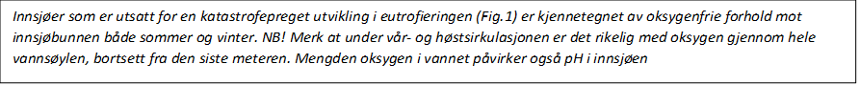

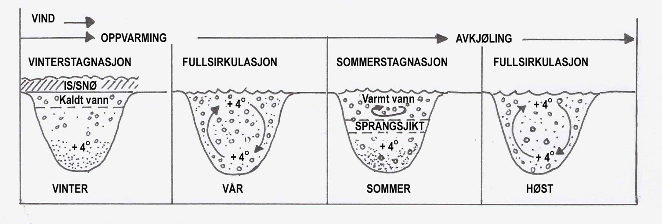
This figure shows how the lake's abiotic conditions change through the seasons due to temperature changes.

Exercise 4.
Temperature
Give a brief description of the temperature curve. Are there any clear "jumps" in the temperature or is there full circulation? Do we have circulation or stagnation in the water?
____________________________________________________________________________________________________________________________________________________________________________________________________________________________________________________________________________________________________________________
Exercise 5.
Give an explanation of your measurement results based on oxygen, temperature, pH and conductivity at the different depths.
_________________________________________________________________________________________________________________________________________________________________________________________________________________________________

Exercise 6.
In summer, it happens that we have over 100% saturation of oxygen in the depth of field. Explain why?
_____________________________________________________________________________________________________________________________________________________________________________________________________________________________

Biotic research
Exercise 7. Plant and zooplankton in the free water masses
Equipment: plankton hoof, dram glass, plastic box for fishing nets (nets set the day before)
You are going out in a boat and take a plankton cover. Use the plankton hoof and pull it after the boat for 5-10 minutes. Shake out the excess water and pour the sample onto the dram glass you have with you. The sample will be examined under a microscope when we enter.
We species determine animals and phytoplankton as far as we can:
Cyanobakterier
Grønnalger

Kiselalger
Gullalger
Andre
Hjuldyr (rotatorier)
Vannlopper
Hoppekreps
Exercise 8: We take up the fish
We go out in a boat and pull pots 3 pcs. Transfer the fish from the pots to a bucket in the boat (alternatively pulling nets). On land we take out the fish and release them in the aquarium. Bring two species in and describe how it is adapted to the habitat.
What fish species did we catch in the pots? Enter in the table. Then examine the fish and describe, based on morphology, how it is adapted to the habitat.
Gjeddefamilien
Abborfamilien
Karpefiskfamilien

Take photos and make notes:
_________________________________________________________________________________________________________________________________________________________________________________________________________________________________

Exercise 9. The fish's adaptations:
SPECIES: ______________________________________
Describe how the fish is adapted to the environment / niche in relation to:
Motion:
______________________________________________________________________________________________________________________________________________________Briefing:
______________________________________________________________________________________________________________________________________________________

Protection against predators: _____________________________________________________________________________________________________________________________________________________________________________________________________________________________________
Oxygen uptake:
______________________________________________________________________________________________________________________________________________________
_______________________________________________________________________________

Food, how are the mouth parts designed: _______________________________________________________________________________________________________________________________________________
Winter survival / generational change:
____________________________________________________________________________________________________________________________________________________________________________________________________________________________________________________________________________________________________________Spread to other areas: _________________________________________________________________________________________________________________________________________________________________________________________________________________________________

Disseksjon av fisk
Velg en fisk og forsøk å finne alle organer og finner hos fisken. Se figur!
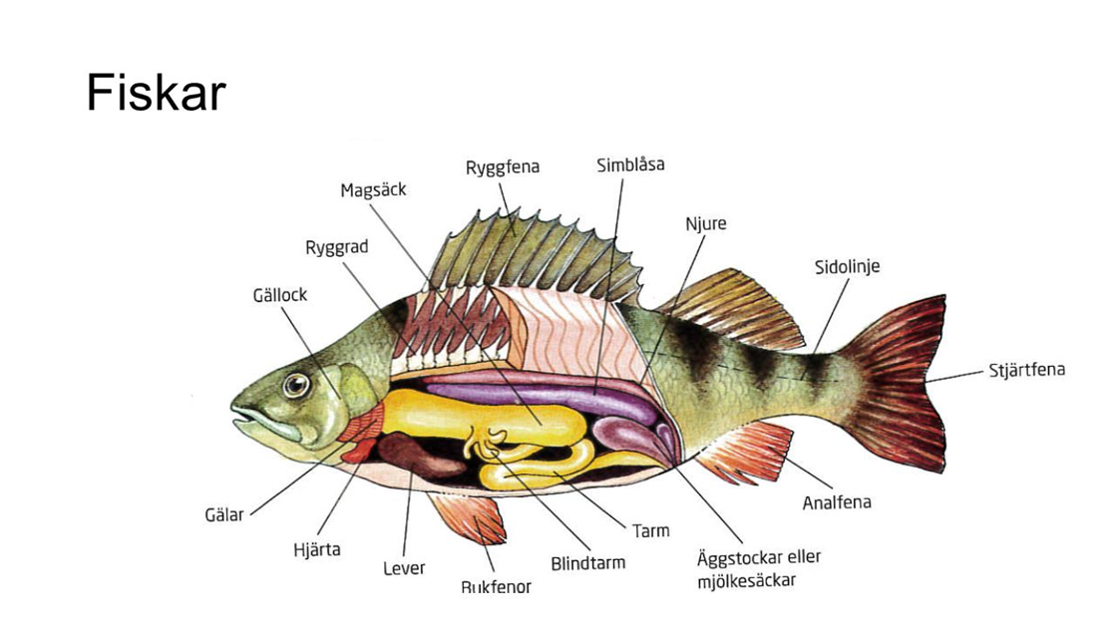
Fiskeart: ____________________________________________________________________
Ta bilder av de ulike organene!

Freshwater organisms
Many freshwater organisms are associated with shallow water and the vegetation there. Some species live their entire lives in freshwater such as water calves. Other organisms have the larval stage in freshwater, but live as adults near freshwater as dragonflies do.
Exercise 10.
Collection of freshwater organisms
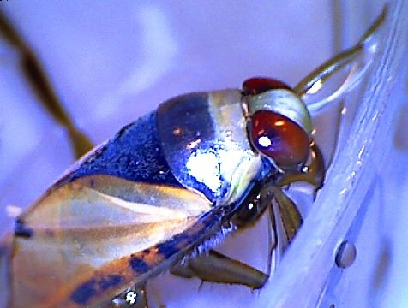
Equipment: Rubber boots, Rod strainer, white plastic tray, tweezers, hand magnifier, petri dish,
Use the rod strainer to catch various animals in shallow water. Feel free to also use waders to get further out.
• Make a Z-sweep with the bar strainer.
• Store the contents in a plastic tray with a little water.
Use tweezers or a small dram glass to catch the animal from the plastic tray and transfer the animal to a dram glass. When you have collected a number of species, take the equipment back to the tables.
Use a magnifying glass and determine the insects as far as you can.
• Make a table of the animal groups, species names, adaptations to life in water in relation to gas uptake, morphology, food uptake and way of life.

Write down the different animal you find and take pictures:
Artsnavn (om mulig) |  | Familie | Orden | Klasse

Which animals are associated with fresh water and which adaptations have been developed.
Equipment: The zoological diversity ", and field handbook" small insects in fresh water ".
Key words for all the tasks are: movement, oxygen supply, withstand dehydration / moisture, orientation, avoiding predators, reproduction, seasons / generational change, food choices and niche.
Insect / organism No. 11
Describe how the insect / organism is adapted to the environment / niche in relation to:
Movement: ______________________________________________________________________________________________________________________________________________________ Orientation: _________________________________________________________________________________________________________________________________________________________________________________________________________________________________protection against predators: _________________________________________________________________________________________________________________________________________________________________________________________________________________________________ Oxygen uptake: ______________________________________________________________________________________________________________________________________________________Dehydration / aquatic life: ______________________________________________________________________________________________________________________________________________________Overlevelse winter / generation exchange: ______________________________________________________________________________________________________________________________________________________Food: ______________________________________________________________________________________________________________________________________________________
Spread: ______________________________________________________________________________________________________________________________________________________
Take pictures!

